**Exercise 1: Control Structures**

BEGIN

EXECUTE IMMEDIATE 'DROP TABLE customers';

EXCEPTION

WHEN OTHERS THEN

NULL;

END;

CREATE TABLE customers (

customer_id NUMBER PRIMARY KEY,

name VARCHAR2(50),

age NUMBER,

interest_rate NUMBER(5,2)

);

INSERT INTO customers VALUES (101, 'Rahul', 65, 12.5);

INSERT INTO customers VALUES (102, 'Sneha', 45, 10.0);

INSERT INTO customers VALUES (103, 'David', 70, 11.0);

INSERT INTO customers VALUES (104, 'Anu', 59, 9.5);

COMMIT;

BEGIN

FOR rec IN (SELECT customer_id, age FROM customers) LOOP

IF rec.age > 60 THEN

UPDATE customers

SET interest_rate = interest_rate * 0.99

WHERE customer_id = rec.customer_id;

DBMS_OUTPUT.PUT_LINE('1% discount applied to customer ID: ' || rec.customer_id);

END IF;

END LOOP;

COMMIT;

END;

/

**OUTPUT**

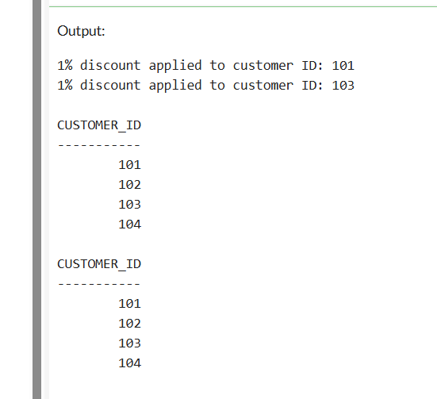O

**Exercise 3: Stored Procedures**

BEGIN

EXECUTE IMMEDIATE 'DROP TABLE customers';

EXCEPTION

WHEN OTHERS THEN

NULL;

END;

-- Create the customers table

CREATE TABLE customers (

customer_id NUMBER PRIMARY KEY,

name VARCHAR2(50),

balance NUMBER(10,2),

isVip CHAR(1) DEFAULT 'N' -- 'Y' for VIP, 'N' for non-VIP

);

INSERT INTO customers VALUES (201, 'dhoni', 9500, 'N');

INSERT INTO customers VALUES (202, 'virat', 15000, 'N');

INSERT INTO customers VALUES (203, 'kohli', 10200, 'N');

INSERT INTO customers VALUES (204, 'rahul', 5000, 'N');

COMMIT;

BEGIN

FOR cust IN (SELECT customer_id, balance FROM customers) LOOP

IF cust.balance > 10000 THEN

UPDATE customers

SET isVip = 'Y'

WHERE customer_id = cust.customer_id;

DBMS_OUTPUT.PUT_LINE('Customer ID ' || cust.customer_id || ' marked as VIP.');

END IF;

END LOOP;

**OUTPUT**

